Paper presented during the academic conference “Challenging relations with(in) East Asia” at the Vytautas Magnus University (VMU, Kaunas, Lithuania) on November 3, 2023.

Aleksandra Görlich

**JAPANESE TEA CEREMONY AS A SPACE FOR CULTURAL RELATIONS**

Japanese culture is famous for the traditional art, such as *ikebana*, ceramics, *chanoyu*. We are delighted by paintings on silk in a form of scrolls or screens. While studying Japanese art we can often point out the time and circumstances when a specific art technique was introduced into Japan and where it came from. One would ask whether these arts are really Japanese if they were inspired by another culture. The answer is always a matter of interpretation.

Today, I would like to present a few aspects of the Japanese tea ceremony utensils, *chanoyu dogū*, that are borrowed from Chinese and Korean cultures along with Japanese elements, and try to answer to another question: Is it possible to create such a unique art and way of life without cross-cultural relations?

The traditional Japanese art history presents clearly how creative and important are the international contacts even though the relations between neighbouring countries are challenging.

Japanese *chanoyu* evolved from tradition of drinking tea that has roots in China, and came to Japan in Heian period (794–1185) with Buddhist monks.

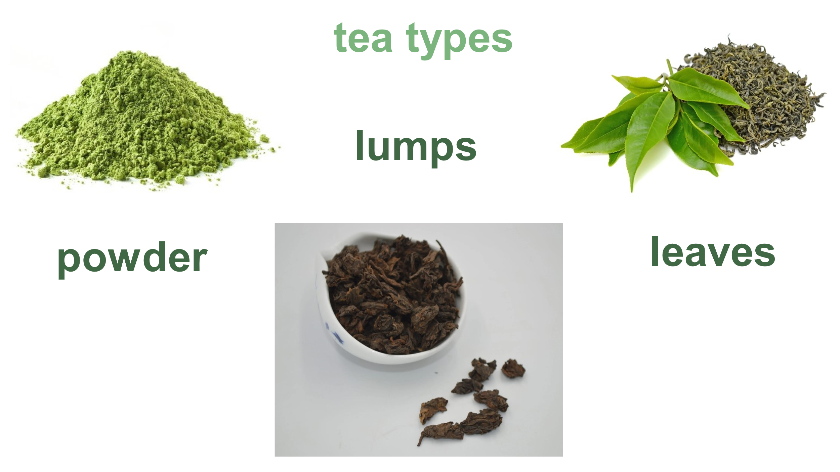

*Ill. 1: Tea types: powder, lumps and leaves.*

There were various kinds of tea prepared in monasteries and at the imperial court: powder, lumps, leaves or pressed tea. Within decades the habit of drinking tea and trust in its health benefits spread among Japanese and in 14th century there were already plantations in villages not related to monasteries. Tea was drunk during official gatherings and it was even a subject of social competition, called *tōcha*, during which guest were to distinguish tea from various plantations based only on its taste. Other kinds of tea gatherings were popularised by Buddhist monks and introduced to the court of Ashikaga Yoshimasa shogun (1436–1490). Some elements of these meetings were borrowed from Chinese culture that was very appreciated among Japanese courtiers. It was already a long tradition of writing in Chinese, painting in Chinese style or using Chinese motives in art because Chinese elements were considered as sophisticated, stylish and confirming one’s wealth.

*Chanoyu*, as it is known today, was formed in 15th and 16th centuries by three masters:

Murata Shukō (1433–1481), Takeno Jōō (1502–1555), and Sen Rikyū (1422–1591). They all knew sophisticated ceremonies from courts although they also admired the *wabi* and *sabi* aspects of life, that is simplicity, humility and a sense of imperfection as it appears in nature. Tea masters who were from the merchant class and had interest in Buddhism did not find Chinese style tea gatherings appealing for them. On the contrary, they introduced to tea meetings those rules according to which everyone who entered a simple tea room ceased to be a samurai, a courtier or a person performing any other official role. Instead became a guest who could enjoy a cup of tea with the host.

One of the elements of tea gathering are ceramic items.

A host uses a *chawan* in which tea is prepared, *mizusashi*, or a jar for fresh water, that is needed for rinsing the tea bowls, or a *kensui* that is a container for already used liquids. These utensils are selected specifically for a tea gathering theme.

*Ill. 2: Sugimoto Sadamitsu, Hagi ceramics, from the Gisela Jahn collection. Source: A. Görlich, Ichigo ichie. Wchodząc na Drogę Herbaty.*

*Ill. 3: Mizusashi, Karatsu ceramics, from the Senshinkai Association collection, photography by Dagmara Sojka.*

*Ill.4: Kensui, Oribe ceramics. Source: https://www.tablinstore.info/product/752.*

In 90s of 16th century Toyotomi Hideyoshi (1537–1598) lead two invasions on Korea (1592, 1596). They were not very successful from the political point of view, but affected seriously Japanese ceramics by capturing and bringing many ceramicists. Since that moment a few new kinds of ceramics has been produced in Japan. Among them Karatsu, Mishima and Hagi.

**Karatsu** takes its name from a harbour city Karatsu where many Korean ceramicists were settled. This kind of ceramics is stoneware with feldspathic glaze. It is rarely decorated, however simple underglaze paintings or engraved motives appear sometimes.

The chawan presented here is in a shape of *idojawan* that resembles a simple Korean bowl for daily use. The most common karatsu ware used for chanoyu are chawan cups an mizusashi, or fresh water containers.

*Ill. 5: Chawan, Nishioka Kojū, Karatsu ceramics, from the Gisela Jahn collection.* *Source: A. Görlich, Ichigo ichie. Wchodząc na Drogę Herbaty.*

**Mishima** ceramics was produced in Korea already in Goryeo (918–1392) and Yi (1392–1910) dynasties times. Most probably the Japanese name, Mishima, came from tea masters’ association of the ceramics decoration with small characters used in writings in the Mishina temple on Izu Peninsula.

These utensils are produced in various colours, although the most popular are grey, beige and white. Motives are pressed with a stamp into still soft clay or cut out, the pattern is filled with a contrasting colour and the whole ceramic ware is covered with a glaze.

The presented container for tea is decorated with flower motives that gave name to this kind of ceramics – Hana Mishima.

*Ill. 6: Usuki, Hana Mishima ceramics, from private collection, fot. E. Mucha.*

**Hagi** ceramics has its origins in two Korean brothers’ workshop in Hagi city. They were Ri Shakko and Ri Kei (who later changed his name to Saka Kōraizaemon and this name is passed down to subsequent generations of the family ceramicists).

The Hagi ceramics is mostly yellow-white and salmon-coloured, sometimes it’s covered with a white, transparent glaze. It has thin walls and looks light. The presented mizusashi is a 20th century piece in a shape mirroring a leather container.

Shukō master found the Korean ceramics as a great one for *chanoyu* purposes and introduced this style into tea gatherings what has been popular until today.

*Ill. 7: Mizusashi, Sakata Deika, Hagi ceramics, from the Gisela Jahn collection.* *Source: A. Görlich, Ichigo ichie. Wchodząc na Drogę Herbaty.*

The Chinese elements, on the other hand, were borrowed from the *tōcha* competitions and imperial and shogunal courts. A room for this kind of gathering was arranged with scrolls, while precious Chinese items (*karamono*) were presented on a shelf.

*Ill. 8: An exceptional heirloom Jian 'nogime tenmoku' tea bowl, Southern Song dynasty and a cinnabar lacquer 'guri' bowl stand, Yuan dynasty. Source: https://www.sothebys.com/en/buy/auction/2023/karamono-heirlooms-of-chinese-art-from-medieval-japan/an-exceptional-heirloom-jian-nogime-tenmoku-tea?locale=en*

The presented chawan is decorated with gold and it is placed on a lacquer stand. Such lacquer elements from China were created on a wooden frame but all layers of the decoration were done in lacquer and only then engraved. It made these art pieces extremely expensive. We can find some lacquer items from 19th century that look similar but they were carved entirely from wood and covered only with thin layers of lacquer.

Also today, Chinese utensils are used for special tea ceremonies to emphasize a unique character of the specific meeting.

In today’s tradition of *chanoyu* one can see a reflection of the Chinese and Korean inspirations when looking at the utensils: ceramics, lacquerware, metal ware, or calligraphy and paintings that illustrate a gathering subject. But there is one more element that highlights the inclusive nature of *chadō*.

As the ancient tea masters found neighbouring countries art appropriate to express the spirit of tea, also nowadays masters teach people around the world the principals of *chanoyu* using often local ceramics and utensils for the tea preparation. This way the intercultural inspirations never end.

Here we can see a mizusashi given by Japanese tea mistress, Yamaguchi Etsuko, to the Senshinkai Association, a Krakow branch of the Urasenke chadō school. It is a jar made in a Polish folk Bolesławiec style.

*Ill. 9: Mizusashi, Bolesławiec ceramics, from the Senshinkai Association collection, photography by Dagmara Sojka.*

Also the other one, a tray for sweets made of wood in Podhale style was ordered for the Senshinkai Association by Yamaguchi sensei. They are both in use during various tea gatherings until today as an emblema of tea spirit that may be felt in every place of the world.

*Ill.10: Bon, Podhale-style wooden tray, from the Senshinkai Association collection, photography by Grzegorz Adamczyk.*

And the spirit of tea as a peaceful contemplation of the world beauty is also shared by Sen Sōshitsu XV (b. 1923), the former head of the Urasenke chadō school. He travels around the world since 1950 and spreads the philosophy of chadō and, among many other activities he does *kenchasihiki*, or offering a cup of tea for world peace. It proceeds every time in completely Japanese style but in places important for the local society, such as it was in 2007 in Krakow, Poland, in the St. Mary’s Basilica, during the holy mass. As we can see, *karamono* were used for this ceremony.

*Ills. 11-12: Sen Sōshitsu XV during kenchashiki, Krakow, St. Mary’s Basilica, July 2007. Source: A. Görlich, Ichigo ichie. Wchodząc na Drogę Herbaty.*

If we come back to the question posed in the beginning of the paper: Is it possible to create such a unique art and way of life without cross-cultural relations?

* we can certainly answer that there would be no chanoyu without Buddhist monks who brought tea to Japan,
* Wabi-sabi style in tea ceramics would be incomplete without Korean ceramics introduced in the 16th century
* elegant style at official tea gatherings and ceremonies would be completely different without Chinese utensils, *karamono*.

These elements are important in chanoyu and together with the spirit of tea they create an idea of sharing joy of each specific moment – *ichigo ichie* – that has been presented in all parts of the world.

Bibliography:

*Görlich, Aleksandra, Ichigo ichie. Wchodząc na Drogę Herbaty, Kraków 2009.*

*Graham, Patricia J., Tea of Sages: The Art of Sencha, Honolulu 1998, pp. 9-22.*

*Hayashiya Tatsusaburō, Nakamura Masao, Hayashiya Seizō, Piękno w herbacie, in: Estetyka japońska. Antologia, ed. Krystyna Wilkoszewska, Kraków 2001, pp. 176-186.*

*Okakura Kakuzō, Księga herbaty, Kraków 2004.*

*Tsunoyama Sakae, Tea and the Culture of Sociability, in: Japan Echo, No. 2, Vol. 33, Y: 2006, pp. 60-64.*

*The author also used materials from the documentation of the Ichigo ichie. An Encounter with a Bowl of Japanese Tea exhibition held by the Manggha Museum of Japanese Art And Technology in 2009.*